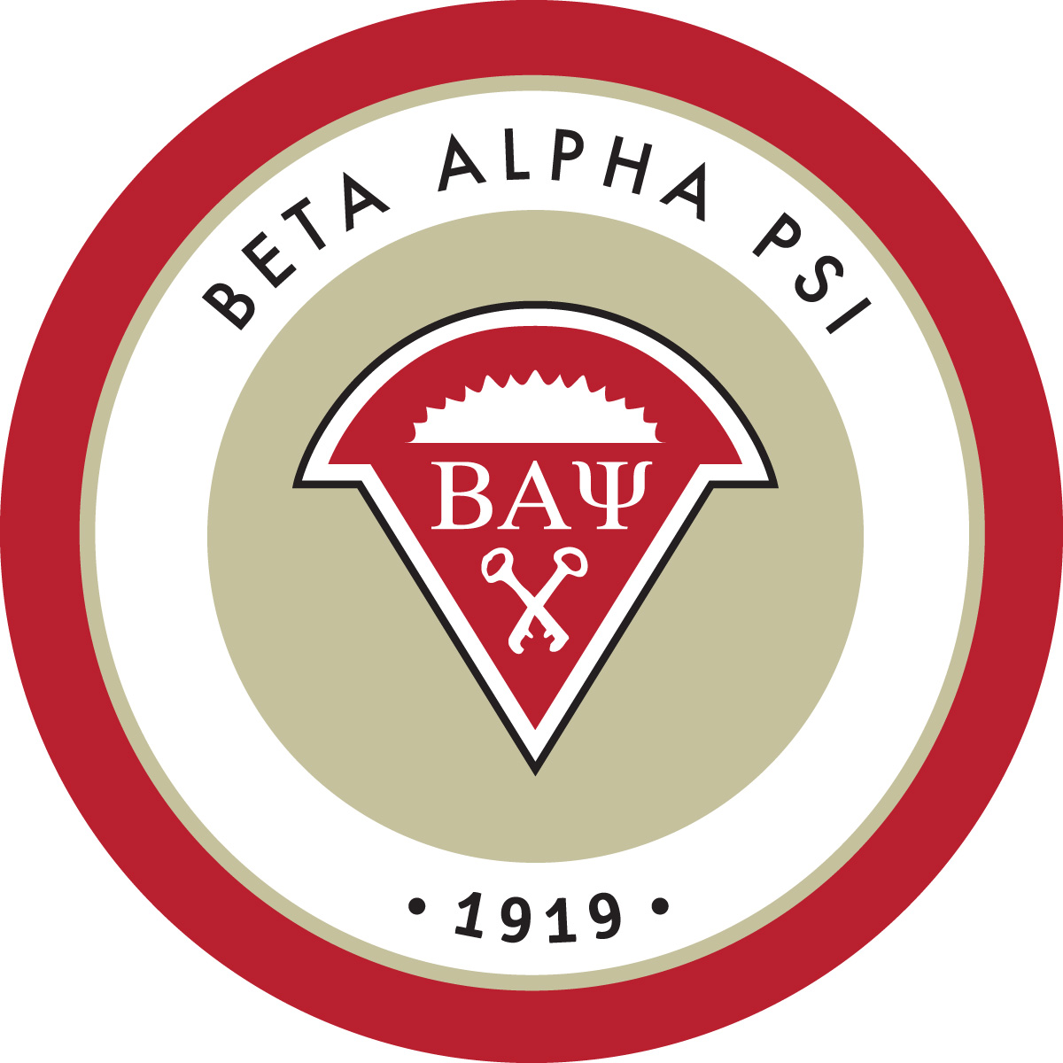

Allen & Susan Simkins Golf Tournament
“Meet the Firms: On the Golf Course”

Friday, September 16
Join us for 9 holes!

Sun Hills Golf Course
3185 N Hills Drive, Layton, UT

1:00 PM Lunch followed by a
Scramble Tournament

Event Pricing
Sponsorship Levels - Platinum and Gold
(See Fall 2016 Event Pricing Summary included in e-mail attachments)
Tee Sponsor – 2 golfers and logo at hole | $ 250
Two Golfers | $ 150
Individual Golfer | $ 80

Register and pay online here

Additional Information
- Players receive green fees, cart, lunch and drinks on the course
- Multiple teams from each firm will be accepted
- Limit of 80 golfers (40 professionals and 40 students)

Company Request for Student Players
Companies may indicate preferences for students with whom they would like to golf. If you have such students in mind, we suggest you sign up early and let us know with which students you would like to be paired. Of course, we can’t guarantee those choices; however, we will try to accommodate as many requests as possible. Platinum and gold level sponsors will receive first preference.

Please e-mail Loisanne Kattelman, BAP Co-Faculty Advisor, at lkattelman@weber.edu for student selections or any questions.

