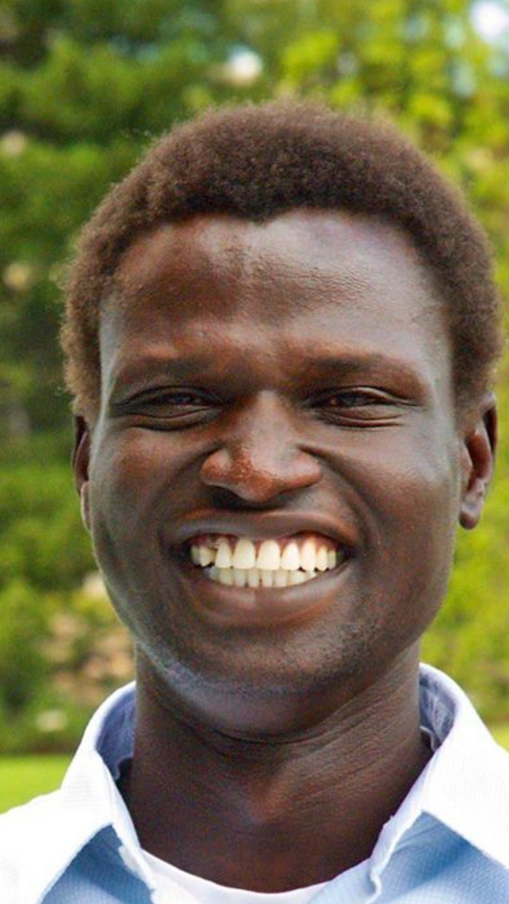
The story of one of the lost boys of south sudan  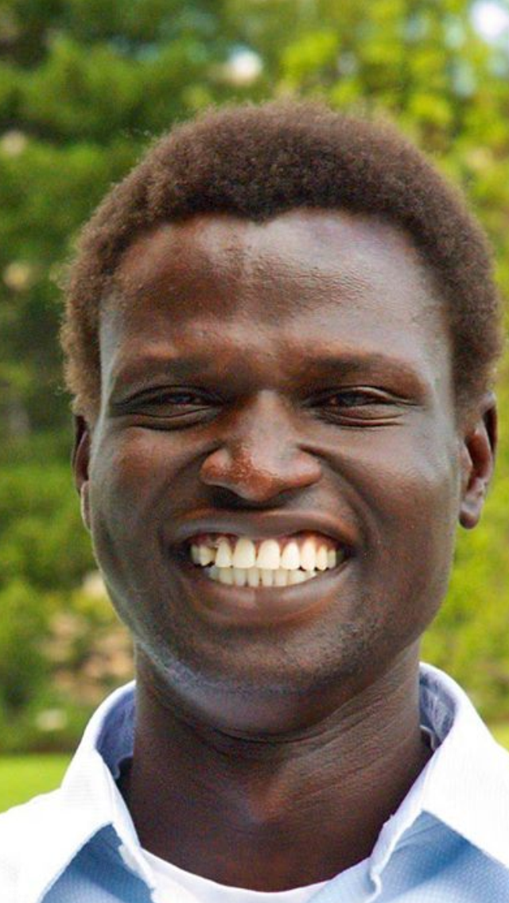  FEATURING  · Dut Bior  CEO & Founder of SOAP International  He is one of about 20,000 boys who were displaced by the Sudanese Civil War, which lasted from 1985-2005. He traveled more than a thousand miles before arriving at a safe refugee camp. He is now working to help other young men and women back in South Sudan through SOAP International. |  |  | Event open to faculty, students, and the community  When  Monday,  February 9, 2015  6pm-8pm  light refreshments served after in the Fireplace Lounge  where  Wildcat Theater located on the main floor around the corner from the book store of the Student Union at Weber State  Sponsors  · Geography Club  · Geography Dept.  · WSU’s Amnesty International Club  · Anthropology Club  · WSU’s BSU – Black Scholars United  · WSU’s Center for Diversity and Unity

