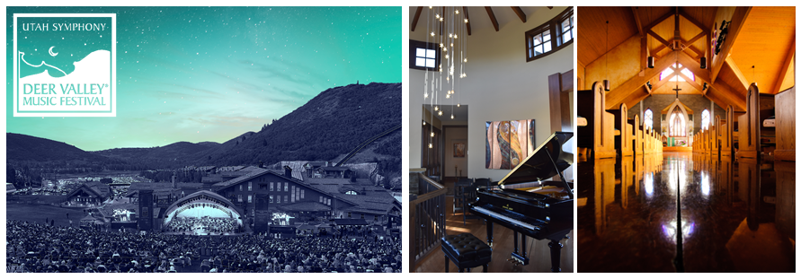

Deer Valley® Music Festival | Development Internship
May 30, 2023 – August 13, 2023
Utah Symphony | Utah Opera’s Development summer intern is responsible for assisting the Development Department with its administrative, presentational, promotional, and onsite operational aspects of the Deer Valley® Music Festival and Symphony State Tour. This individual will interact with patrons, individual donors, corporate sponsors, orchestra members, and guest artists, therefore, a professional and mature demeanor is required. Individuals with an interest in Arts Management, Non-Profit Fundraising, or Event Planning are encouraged to apply.

Duties may include but are not limited to:
- Assisting with the Deer Valley® Music Festival VIP program (check-in, receptions, ticket assistance)
- Weekday office work in Salt Lake City, UT
- Friday and Saturday night concert duty in Park City, UT (Concerts at Snow Park Lodge)
- Occasional weeknight event duty in Park City, UT (Salon events in private homes)
- Contacting VIPs and tracking RSVP lists for events throughout the summer
- Assisting and traveling with USUO on its “Music Elevated” State Tour (August 7-12)
The work schedule is flexible (allowing for days/evenings off each week) and will be negotiated before the internship begins. The candidate would ideally have superior customer service skills when dealing with patrons over the phone and face-to-face. Candidates should be proficient in Excel, Word, and Outlook. Knowledge of the design website WordFly and of the ticketing and fundraising database system Tessitura is a plus, though not required.

The benefits of a Deer Valley® Music Festival internship include:
- $1,500 stipend
- Lodging in Park City during weekend festival work
- Dinners provided during weekend festival work and at other evening events
- Lodging and food during the state tour
- Opportunities to attend performances and receive complimentary/discounted tickets
- Opportunities to meet prominent artists in various music fields
- Increased understanding of the performing arts and arts administration
- Opportunities to learn from top administrative professionals in the performing arts field
Internships begin May 30, 2023 and end on August 12, 2023. The internship start date could be flexible depending on the applicant. Applications are due by Friday, March 17. Application materials should include a resume and cover letter. Please send resume and cover letter to jobs@usuo.org

