Spend your summer with Utah Symphony!

Deer Valley® Music Festival
Summer Operations Internship
The Utah Symphony | Utah Opera announces summer internship opportunities for its 19th annual Deer Valley® Music Festival (DVMF) and Summer Community Concerts.

The Operations Intern will be responsible for assisting with guest artist hospitality, artist transportation, and concert operations. The individual will have the opportunity to work with a world-renowned orchestra and stars from classical, pops, country, and Broadway music. College students with an interest in Arts Management, Stage or Production Management and Orchestra Operations are encouraged to apply. This is a great opportunity to get an in-depth, behind the scenes look at what it takes to run a summer music festival with an orchestra.

The internship will involve evening events and include both office work and onsite event duties with a varied schedule. We are able to offer a stipend of $1500, free tickets to DVMF concerts and meals during weekend concert duty. Housing for all or part of the internship dates may also be available.

College students pursuing a Bachelor’s or Master’s degree should apply. The ideal candidate will have superb interpersonal skills, an excellent driving record, experience working with Microsoft Office, and be at least 21 years old. Experience in the hospitality industry and working with performing artists is a plus.

DVMF is Utah Symphony | Utah Opera’s (USUO) summer home in the mountain resort town of Park City, Utah. DVMF is celebrating its 19th year of providing chamber music, classical, and pops offerings in several venues: Deer Valley Resort Snow Park Outdoor Amphitheater, St. Mary’s Church and salon events in private homes in the Park City area. DVMF aims to deliver high quality and musically diverse experiences in casual settings of unparalleled natural beauty.

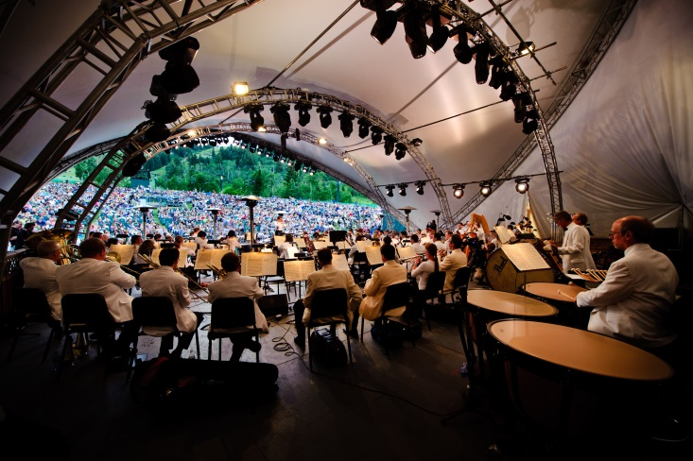

Applications are due March 25, 2023. Application materials include a resume and cover letter. Interested applicants should contact Jen Shark, Operations Manager: JShark@usuo.org

