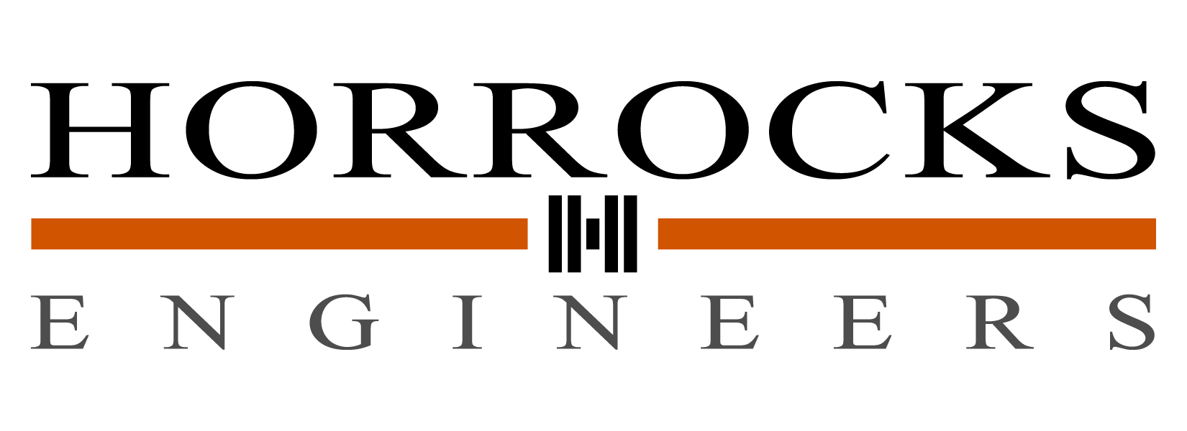

COMMUNICATIONS COORDINATOR

Horrocks Engineers is looking for a career and goal-oriented individual to join our fast-paced and growing Communications Department. The full-time, entry-level position is located in our Pleasant Grove, Utah, office and will require excellent technical writing skills, intermediate Adobe Creative Suite skills, communication skills, and the ability to follow instructions and work in groups. The Communications Department is responsible for internal and external company communications, which includes: regional marketing; project strategizing; writing and producing marketing materials and company documents; event management; public relations; community involvement; media relations; and producing technical illustrations and graphics as needed. Applicant must have a Bachelor’s degree in Communications, English, Marketing, or equivalent.

At Horrocks Engineers, we provide our employees with a highly competitive salary and benefits package, 401k, excellent health and dental insurance, vacation, sick, and holiday pay. Horrocks Engineers may identify additional skills and requirements for the hiring process. Only applicants selected to interview will be contacted. For a confidential interview in Utah, send resume to Lori Pratt at lorip@horrocks.com.

See our website at www.horrocks.com for more information about our company.

