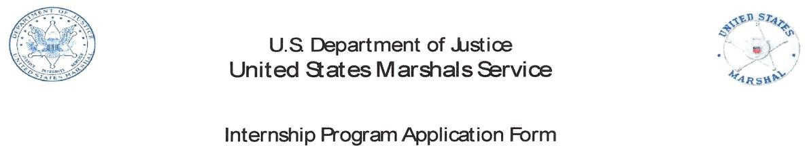
U.S. Department of Justice

United States Marshals Service

Student Volunteer Internship Program Application Form

Desired Term and Year:

Desired Internship Location:

Full Name:

Sex: DOB: SSN: Place of Birth (State):

School: GPA:

School Address:

Permanent Address:

Degree: Affiliated Program (if applicable):

Hours per Week Available to Work: _ Date available to start:

Day Phone: Night Phone: e-mail:

Additional Notes/Information:

My statements on this application are true, complete, and correct to the best of my knowledge and belief and are made in good faith. I understand that a knowing and willful false statement on this form can be punished by fine or imprisonment, or both (See section 1001 of the title 18 United States Code).

Signature: Date:

Form Updated March 16, 2017

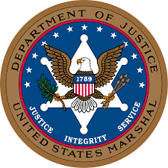

United States Marshal Service Internship Opportunity
You will work with Deputies and Administrative Staff from the U.S. Marshals Service Office in Salt Lake City, UT for a semester and observe first-hand the duties and responsibilities of the men and women who comprise the nation’s oldest federal agency. These responsibilities include, Judicial Security, Prisoner Services, and Fugitive Investigations. You may also be able to take part in various training activities to include arrest techniques, room and building clearing scenarios and firearms training.
Internship Available: Summer Semester, 2020
Deadline: February 18, 2020
Agency Minumium Qualifications:
-Be a Junior or Senior with at least 3.0 GPA (depends on college requirements)
-Be a United States Citizen
-Persuing a degree tied in to the Criminal Justice, or Public Administration (depends on college requirements)
-Receive a recommendation for University Faculty
-Complete an Interview
-Pass a Background Investigation
Agency Preferred Qualifications
- Excellent communication skills both verbally and in writing
- Ability to interact with the public and high-ranking government officials
- Proficient in Microsoft Excel, Publisher, and PowerPoint
- Strong analytical skills and ability to consume large amounts of data and to present data in public
Internship Description: Unpaid

Investigative Ops (30%) Data analysis, compiling arrest data, use of USMS computer systems, data entry. May include show and observe enforcement Deputies (Class 1, Task Force VFAST, OCDEFT)
Court Operations (30%) Attend court hearings, work in the cellblock, shadow the Civil Process Deputy, and assist with other projects as they arise
Firearms Training (5%) Meet with a Firearms Instructor to go over the USMS Course of Fire and go on the range
Judicial Security Unit (5%) Shadow Judicial Security Inspector on daily duties and courthouse operations
Collateral Duties (20%) Assist Deputies with collateral duties such as Motor Vehicles, Property, or Training
District Management (5%) Meet and greet with other federal agencies such as Probation, Pre-Trial, FBI, DSS, ICE, etc.
Purpose of the Internship: The US Marshal Service Inters are held to a high standard of excellence and conduct. Our program is designed to expose you to the missions of the Department of Justice and the Marshals Service.
Additional Information: Applicants must be fingerprinted and pass a criminal background check prior to acceptance into the program. This process usually takes 60 days or more.
To Apply: Please contact Dr. Bruce Bayley in person at the Lindquist Hall, 3rd floor, or by E-mail (bbayley@weber.edu).
Expected Contact: We will contact you via e-mail, or phone for the Interview, and if selected will supply you with the application packet and more information about what to expect during the application process and the internship.
Agency / Organization Website Link: https://www.USMarshals.gov

