Welcome to Weber State University’s Entrepreneurship Certificate program! If you are a degree-seeking Weber State student, you will automatically receive an Entrepreneurship Certificate when 10 credits in the program are completed with a C- or better. The following instructions only apply to those NOT seeking a degree.

If you are not a current Weber State student working towards a degree and just desire to complete the Entrepreneurship Certificate, you will find step-by-step instructions below on how to register for courses. If you have already been admitted to Weber State University, you can skip STEPS 2-3.

Computer Prerequisites: You will need a device with a modern web browser, such as a computer or mobile tablet. An internet connection is required (high speed recommended).

NOTE: To learn more about the internet browser requirements for the Canvas learning management system, please visit: http://guides.instructure.com/m/4214/l/41056-which-browsers-does-canvas-support.
STEP 1: For a listing of available courses in the Entrepreneurship Certificate, scroll half-way down this page under the heading 'Select From These Available Courses.'

NOTE: You must complete 10 credits and pass each course with at least a C- grade to receive the Certificate. You can spread the courses out multiple semesters instead of taking all at once, unless you have ample time. The grades you earn will also be recorded on your Weber State University transcript.
STEP 2: You must apply for admission to Weber State University at getintoweber.com.

NOTE: If you are new to Weber State University, you'll need to apply and register for courses as a new student even if you are not seeking a degree. When applying for the Entrepreneurship Certificate program, please mark non-degree seeking. You may get an email requesting high school transcripts, which can be ignored. There may be some minor registration fees involved with registration.

Once you have been admitted, you will receive a W#. This is a private 8-digit identity number that never changes, which Weber State uses to identify you in administrative databases.

STEP 3: You will need to activate a WSU Wildcat online account. A Wildcat account is your personal and private key to electronic access to Weber State University. Your Wildcat account will allow you to complete WSU online class work, and perform many other activities vital to your education at the University. To activate your Wildcat account and set up a username and password go to: https://portalapps.weber.edu/getwcid/.

NOTE: Your Wildcat account username is not the same as your W#.

STEP 4: You will need to login to your eWeber portal to select and register for classes. You can do so by going to https://cas.weber.edu/login and typing in your username and password created in Step 4.

Once logged in to the eWeber portal, look for the 'Search for Portal Apps…' search bar at the top of the screen:

Type 'Register for Classes (Add/Drop)':

Select the correct app:

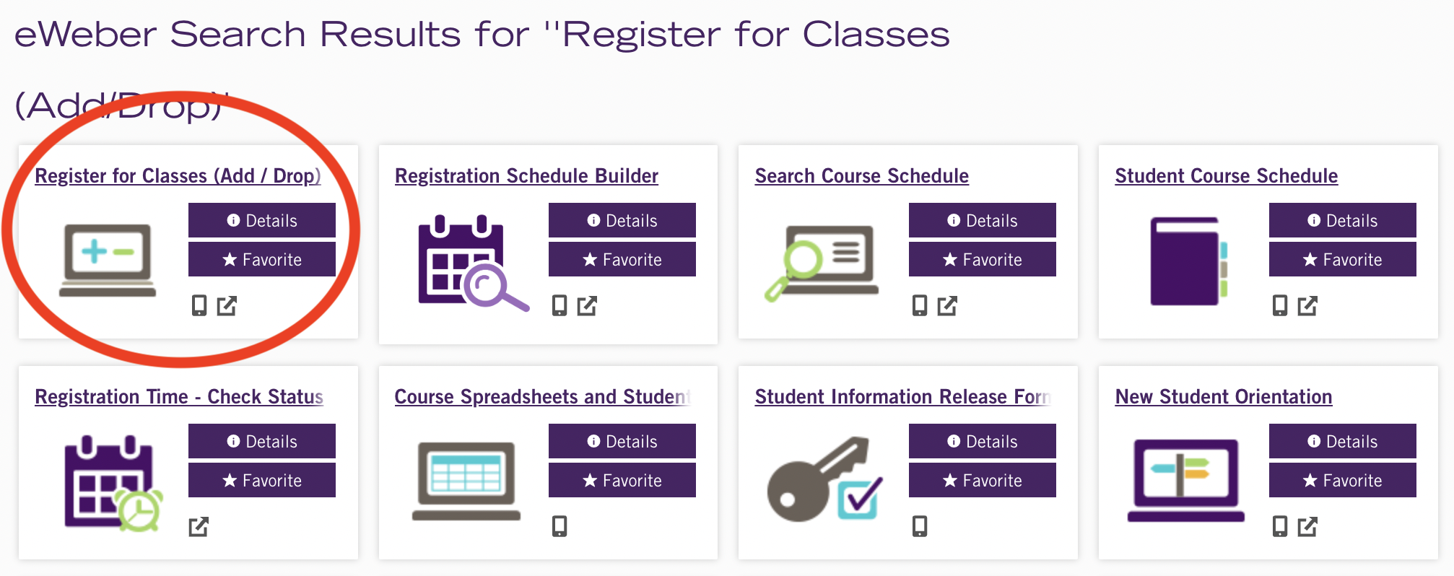

You will need to select the correct semester at the top of the screen and confirm the semester at the bottom.

You will then select 'Register for Classes' from the six available menu options:

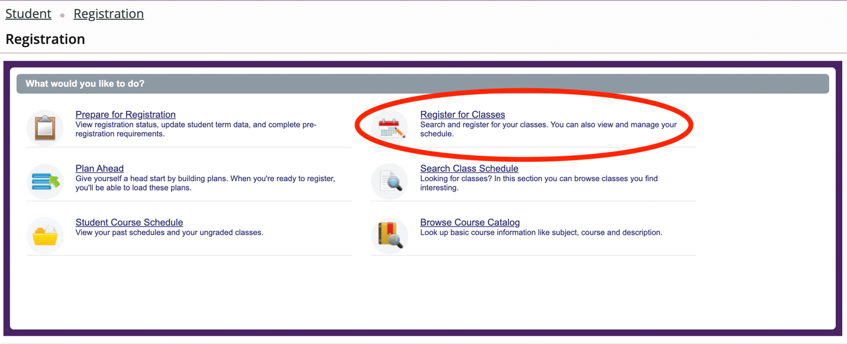

Please select 'Student' and then the corresponding semester again. Next, please click 'Enter CRNs' (stands for Course Record Number) at the top of the menu bar as shown in this graphic:

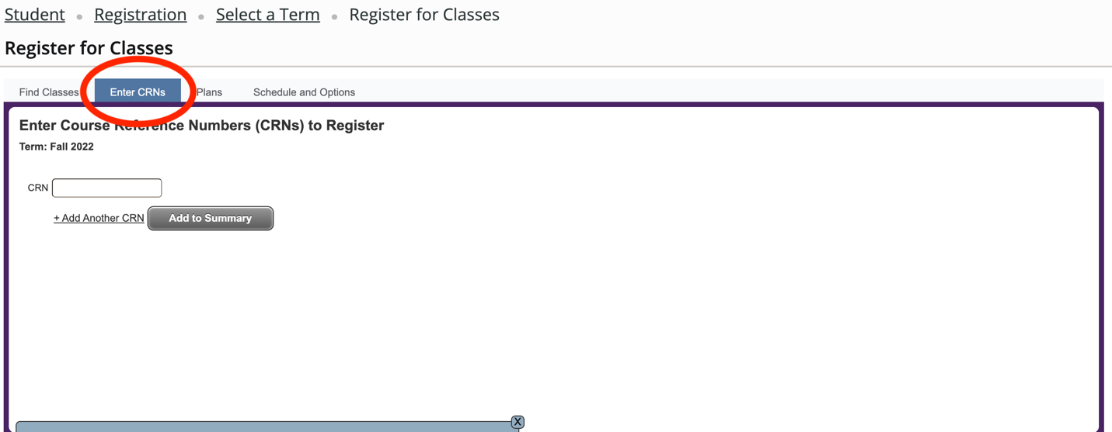

You must enter the CRNs as listed below to get into the correct classes. If you do a search any other way, you'll end up in the wrong courses, even though the names are the same.
Subj | Num | CRN | Course Title
ENTR | 1002 | 23508 | Startup Innovation
ENTR | 2006 | 23513 | E-Commerce for Small Business
ENTR | 2007 | 23514 | Product Design & Prototyping
ENTR | 2008 | 23515 | Legal Foundations Small Bus.
ENTR | 2009 | 23516 | Money Management Small Bus.
ENTR | 2010 | 23517 | Funding For Small Business
ENTR | 2011 | 23518 | Results-Focused Leadership
ENTR | 2012 | 23519 | People Mgmt for Small Business
ENTR | 2005 | 23512 | Product to Market
ENTR | 2002 | 23509 | Marketing Strategy Small Bus
ENTR | 2004 | 23511 | Branding for Small Business
ENTR | 2003 | 23510 | Marketing Execution Small Bus
ENTR | 3002 | 23520 | Scale & Exit

To access your WSU Online course you can login through the eWeber portal and select the Canvas app or go to: http://canvas.weber.edu. Simply enter your Wildcat username and password to login. From the Courses & Groups list (mouse over Courses & Groups) select the name of your class to access the course materials.
NOTE: The course and its content may not be available until the first day of class.

For Further Assistance: If you experience problems logging into your course, please contact the Canvas Help Desk: 801-626-6188 or 877-215-0831. If after 5:00 pm or on weekends, please send an email to LMSsupport@weber.edu.

General Technology Issues, Log-In and Technical Support: Registration, Payment, General Questions call 801-626-6600 (Continuing Education).
You will want to login to the course and get going during the first week of class. If you experience any difficulties please contact Weber State immediately.
Thank You for choosing Weber State University to meet your educational needs!

