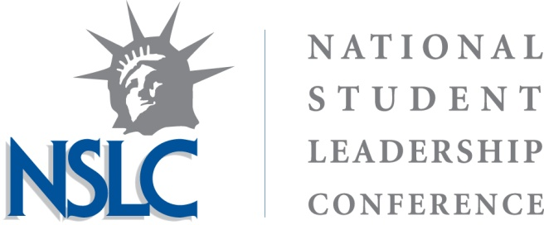

PSYCHOLOGY & NEUROSCIENCE
American University, Washington, D.C. Harvard University, Boston, MA
Vanderbilt University, Nashville, TN

About the Job
Team Advisors guide high school students through their NSLC experience. Each TA is responsible for a small group of 12-16 students. As a TA, you will: lead small group discussions and debriefs, teach academic and leadership sessions, assist Administrative staff, Professors and Leadership Facilitators with program components, serve as a chaperone during off-campus trips and evening social activities, and reside in the dormitory on the same floors as students, serving as a Resident Advisor. Team Advisors are generally current college sophomores – seniors. Current freshman are generally considered for one of our Assistant Team Advisor positions. NSLC has a primary focus on leadership development. Applicants should have leadership experience and/or training. Our programs include TA-led sessions that require appropriate educational backgrounds and work/volunteer/intern experience. If hired, applicants will receive a stipend as well as housing and food for the duration of the summer. NSLC will cover traveling to and from the site.

About the National Student Leadership Conference
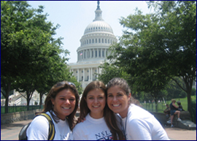
Since 1989, thousands of outstanding high school students from across the United States and more than 45 countries have come to the NSLC to explore the qualities of leadership and get an insider’s perspective on some of today’s most exciting and important professions. Over the past twenty-three years, the NSLC has created programs in law, business, medicine, engineering, education, politics, psychology, diplomacy, forensic science, and mass communication. The NSLC allows students to explore a career, experience college life and degree programs, acquire new leadership skills, make new friends, meet with leading professionals and experts, visit prominent organizations, and tour new cities.

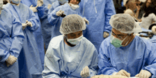
About the Psychology & Neuroscience Program
Each NSLC program is designed to help students see the vast number of careers available within their area of interest. The program’s academic lectures and hands-on simulations are taught at a college freshman level. Throughout the conference, the students will learn from various college professors; hear from guest speakers; visit facilities suce as the APA; take part in experiments and demonstrations in research labs; test their skills during hands-on clinical neuroscience workshops; experience the diagnostic process during a clinical diagnostics simulation; participate in transformative leadership trainings; and tour the historical landmarks of Washington, D.C, Boston MA, or Nashville, TN.

More Information:
About NSLC: http://www.nslcleaders.org

About the Psychology & Neuroscience program: http://www.nslcleaders.org/psychology-neuroscience
Job Application: https://www.nslcleaders.org/about-summer-youth-programs/job-opportunities/

Contacts: Francine Erfe, Program Director for American University
francine.erfe@nslcleaders.org

Caitlyn Dion, Program Director for Harvard Universtiy
caitlyn.dion@nslcleaders.org

Alex Rains, Program Director for Vanderbilt University
alex.rains@nslcleaders.org

