Name of Event: WSU Medical Academy
Category: Science, Full-day Summer Camps
Age: 15-18 (H.S. Juniors & Seniors)
Logo:

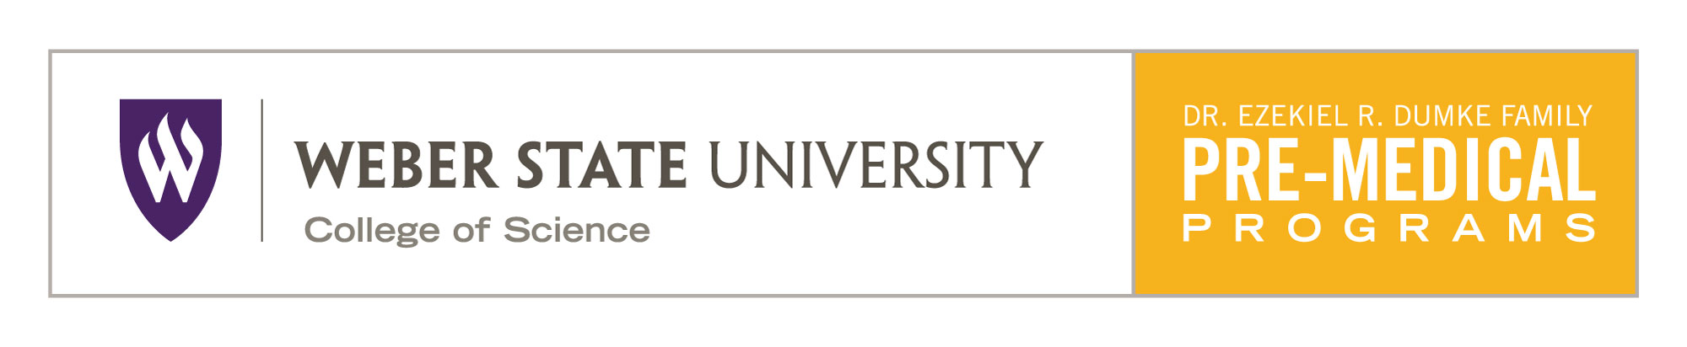

Dates: June 7 - 10, 2017

WSU Organizations Hosting the Event: Dr. Ezekiel R. Dumke Family Pre-Medical Professional Program and the WSU American Medical Student Association

Brief Description: The WSU Summer Medical Academy is designed for high school juniors and seniors to help them determine if a career in the healthcare industry is right for them. This camp will provide valuable information in how the students can best prepare for admission to professional school and make the most of their college experience. WSU faculty members will lead discussions and hands on laboratory activities. Attendees will also get to see human cadavers and rub shoulders with local physicians and other healthcare professionals. This will provide invaluable opportunities for the students in attendance to network with WSU professors and other professional specialists that will aid them in their endeavors.

Location: WSU Campus (Attendees will stay in WSU dormitories and will remain on campus for the entire event).

Cost: $250, includes lodging, meals, and supplies for all labs and activities.

Contact Information: Dr. Jason Fritzler, Pre-Medical Professional Program Director, jasonfritzler@weber.edu, 801-626-7758

